*Git Reset :
The term reset stands for undoing changes. The git reset command is used to reset the changes. The git reset command has three core forms of invocation. These forms are as follows.
Soft
Mixed
Hard
1. What is a version control system (VCS)?
A VCS keeps track of the contributions of the developers working as a team on the projects. They maintain the history of code changes done and with project evolution, it gives an upper hand to the developers to introduce new code, fixes bugs, and run tests with confidence that their previously working copy could be restored at any moment in case things go wrong.

. Differentiate between git pull and git fetch.
git pull | git fetch
This command pulls new changes from the currently working branch located in the remote central repository. | This command is also used for a similar purpose but it follows a two step process:  1. Pulls all commits and changes from desired branch and stores them in a new branch of the local repository.  current  2. For changes to be reflected in the current / target branch, git fetch should be followed by git merge command.
git pull = git fetch + git merge

*What is webhook in GIT?
Ans: Webhook is used to enable auto build, with jenkins or any other CI/CD tools.
*How to enable webhook in git?
Ans: In git --> go to profile --> go to settings --> Search for webhook Enable it..

* what is SubGit?
SubGit is a tool for migrating SVN to Git. It creates a writable Git mirror of a local or remote Subversion repository and uses both Subversion and Git if you like.
*how can you clone a Git repository via Jenkins?
First, we must enter the e-mail and user name for your Jenkins system, then switch into your job directory and execute the “git config” command.

*How to resolve a conflict in Git?
The following steps will resolve conflict in Git-

Identify the files that have caused the conflict.
Make the necessary changes in the files so that conflict does not arise again.
Add these files by the command git add.
Finally to commit the changed file using the command git commit
*Describe the branching strategies you have used?
Feature branching – A feature branch model keeps all of the changes for a particular feature inside of a branch. When the feature is fully tested and validated by automated tests, the branch is then merged into master.

Task branching – In this model, each task is implemented on its own branch with the task key included in the branch name. It is easy to see which code implements which task, just look for the task key in the branch name.

Release branching – Once the develop branch has acquired enough features for a release, you can clone that branch to form a Release branch. Creating this branch starts the next release cycle, so no new features can be added after this point, only bug fixes, documentation generation, and other release-oriented tasks should go in this branch. Once it is ready to ship, the release gets merged into master and tagged with a version number. In addition, it should be merged back into the develop branch, which may have progressed since the release was initiated.

*how to clone git repository without using clone command
1. Create directory and enter it. mkdir Moment cd Moment.
2. Create empty git repo. $ git init . ...
3. Add remote. The empty git repo that we have creates in the previous step has no remotes. ...
4. Fetch everything from remote. ...
5. Switch working directory to the state.
**Maven:
What is POM?
POM stands for Project Object Model. The pom.xml file contains information of project and project configuration.
What do you mean by a Maven Repository?
Answer: Maven repository is the location of a directory where all the related project artifacts, jars, libraries, plugins are kept and can be utilized by Maven easily.
Name the build phases in Maven Build Lifecycle.
Answer: The build phases in Maven Build Lifecycle are listed down:
-Validate: Checks if all the preconditions information to trigger the build is obtained.
-Compile: Project source code is compiled.
-Test: The Source code that is compiled is tested with the unit test framework. In this phase, the code is not deployed or packaged.
-Package: Source code after compilation is packaged in the form of ZIP or JAR files.
-Integration- test: After the package is deployed in an environment, the integration test cases are executed.
-Verify: Examines to ensure that the package is correct and it meets all the required quality specifications.
-Install: Installation of packages into the local repository.
-Deploy: A specimen of the final package is made accessible to the remote repository for distribution among the other developers across projects.

* Name the phases of the Maven Clean Lifecycle.
Answer:
The phases of Maven Clean Lifecycle are listed below:
-pre-clean
-clean
-post-clean
***Docker::
*What is Docker:
Docker is a very popular and open-source containerization platform that is used for building, deploying, and running applications. Docker allows you to decouple the application/software from the underlying infrastructure.
*Difference between Docker Image and container?
Ans: Docker container is the runtime instance of docker image.
Docker Image doesn't have a state and its state never changes as it is just a set of files whereas the docker container has its execution state.
*How packages are release in your organization?- One in month or quarter
*How to manage docker images?-Through docker Hub
*How to stop and restart the Docker container?
To stop the container: docker stop container ID
Now to restart the Docker container: docker restart container ID
* Is there a possibility that a container can restart all by itself in Docker?
Ans: To answer this question blatantly, No, it is not possible. The default –restart flag is set to never restart on its own. If you want to tweak this, then you may give it a try.
*Suppose you have 3 containers running and out of these, you wish to access one of them. How do you access a running container?
The following command lets us access a running container:
$ docker exec -it <container id> bash
The exec command lets you get inside a container and work with it.

* Can you remove a paused container from Docker?
The answer is no. You cannot remove a paused container. The container has to be in the stopped state before it can be removed.

*Can a container restart by itself?
No, it’s not possible for a container to restart by itself. By default the flag -restart is set to false.
*Is it better to directly remove the container using the rm command or stop the container followed by remove container? :
Its always better to stop the container and then remove it using the remove command.
$ docker stop <container_id>
$ docker rm -f <container_id>

Stopping the container and then removing it will allow sending SIG_HUP signal to recipients. This will ensure that all the containers have enough time to clean up their tasks. This method is considered a good practice, avoiding unwanted errors.

*If you wish to use a base image and make modifications or personalize it, how do you do that?
You pull an image from docker hub onto your local system:
It’s one simple command to pull an image from docker hub:
$ docker pull <image_name>

*What is Docker Swarm?
Docker Swarm is native clustering for Docker. It turns a pool of Docker hosts into a single, virtual Docker host. Docker Swarm serves the standard Docker API, any tool that already communicates with a Docker daemon can use Swarm to transparently scale to multiple hosts.

*What are the most commonly used instructions in Dockerfile?
FROM: This is used to set the base image for upcoming instructions. A docker file is considered to be valid if it starts with the FROM instruction.
LABEL: This is used for the image organization based on projects, modules, or licensing. It also helps in automation as we specify a key-value pair while defining a label that can be later accessed and handled programmatically.
RUN: This command is used to execute instructions following it on the top of the current image in a new layer. Note that with each RUN command execution, we add layers on top of the image and then use that in subsequent steps.
CMD: This command is used to provide default values of an executing container. In cases of multiple CMD commands the last instruction would be considered.

*What is the way to establish communication between docker host and Linux host?
This can be done using networking by identifying the “ipconfig” on the docker host. This command ensures that an ethernet adapter is created as long as the docker is present in the host.
***Jenkkins:*****

*what is a Jenkins Pipeline?
Jenkins Pipeline (or simply “Pipeline”) is a suite of plugins which supports implementing and integrating continuous delivery pipelines into Jenkins.
*Question: Explain the difference between Continuous Integration, Continuous Delivery, and Continuous Deployment?
Answer: Continuous integration: It is the process of constantly integrating the changes into the main software during all the stages of the delivery pipeline, once the changes are tested on the test environment. CI can also be referred to as the work done by the Jenkins or Bamboo server.
Continuous delivery: It is the delivery of code (shipping) to a particular environment like test, integration or production through a manual release.
Continuous deployment: It is the automatic release of code into the staging or production environment, once the testing is done in the CI stage.
*Difference between “poll scm” and “build periodically”
Poll SCM will trigger the build only if it detects the change in SCM, whereas Build Periodically will trigger the build once the given time period is elapsed.
*What are Scripted Pipelines in Jenkins?
Answer: Scripted Pipeline follows Groovy Syntax as given below:
Node {
}
In the above syntax, the node is a part of the Jenkins distributed mode architecture, where there are two types of node, Master which handle all the tasks in the development environment and the Agent is being used to handle multiple tasks individually.
* What are Declarative Pipelines in Jenkins?
Answer: Declarative Pipelines are the newest additions to Jenkins that simplify the groovy syntax of Jenkins pipelines (top-level pipeline) with some exceptions, such as:
No semicolon to be used as a statement separator. The top-level pipeline should be enclosed within block viz;
The common syntax is:
pipeline {
/* Declarative Pipeline */SSSS
}
* What is a Multi-branch Pipeline?
A multi-branch pipeline is a concept of automatically creating Jenkins pipelines based on Git branches. It can automatically discover new branches in the source control (Github) and automatically create a pipeline for that branch

* Let us say, you have a pipeline. The first job was successful, but the second failed. What should you do next?
You just need to restart the pipeline from the point where it failed by doing ‘restart from stage’.
*I have 50 jobs in the Jenkins dash board, I want to build at a time all the jobs
In Jenkins there is a plugin called build after other projects build. We can provide job names over there and If one parent job run then it will automatically run the all other jobs. Or we can use Pipe line jobs.
*Did you automate anything in your project? Please explain
Yes I have automated couple of things such as
- • Password expiry automation
- • Deleting the older log files
- • Code quality threshold violations etc.
*How can you avoid the waiting time for the triggered jobs in Jenkins.
First I will check the Slave nodes capacity, If it is fully loaded then I will add the slave node by doing the following process.
Go to the Jenkins dashboard -> Manage Jenkins ->Manage Nodes Create the new node a
By giving the all required fields and launch the slave machine as you want.

*What is a backup plugin? Why is it used?
This is a helpful plugin that backs up all the critical settings and configurations to be used in the future. This is useful in cases when there is a failure so that we don’t lose the settings.

*In Jenkins, what is the default port?
Jenkins’ default port is 8080.

* Explain how to create a backup and copy files in Jenkins?
Ans: Jenkins saves all the build logs and configurations in the home directory. It includes all the slave node configurations and job configurations. For the performing back of Jenkins, you should back up the JENKINS_HOME directory frequently. For copying Jenkins jobs, you should replicate the job directory.

*What are the different ways of scheduling a build in Jenkins?
Ans:
Builds can be triggered by source code management commits sequentially.
Manual requests the Builds.
Can be scheduled to run at a specified time using the CRON jobs.

*What are the basic permissions set of any user's in Jenkins?
Ans: For any user by default permission is read-only

*Which version of Jenkins you are using now?
Ans: I am using the current version of Jenkins which is 2.25. This is also printed on bottom right of Jenkins.
*What are the Plugins you have used in Jenkins mostly and why?
Named five at least. Ans: git plugins, maven plugin, Build Pipeline Plugin, Copy Artifact Plugin, JIRA Plugin for Jenkins, Mask Passwords Plugin.
*How will you secure Jenkins?
Ans: The following ways will help you to secure Jenkins:
Check the global security is on.
Make sure Jenkins is integrated with the appropriate login with my company’s user directory.
The project matrix/matrix is allowed to fine-tune access.
Automate the process of setting rights/privileges with custom version controlled script in Jenkins.
Limit physical access to Jenkins data/folders.
Run security audits periodically on the same.
*How do you integrate Git with Jenkins?
Ans: The below steps show you how to integrate Git with Jenkins:
Manage the Jenkins button on your Jenkins dashboard.
Click on Manage Plugins.
In the Plugins Page
Select the GIT Plugin and click on Install without restart.
You can also select the option Download now and install after restart.
If you already have the Git plugin installed, you will see a “No updates available” message.
Go to Manage Jenkins on your Jenkins dashboard.

*What is DSL Jenkins?
Ans: Job DSL is one of the most important plugins for Jenkins that allows managing configuration as code. It is made up of two parts. First, Domain Specific Language (DSL) that enables users to define jobs utilizing a Groovy-based language, and second, a Jenkins plugin that manages the scripts and updates the created Jenkins jobs.

*****Kubernates:
*Which kubernates version you are using currently: 1.7
*Explain Kubernetes Architecture
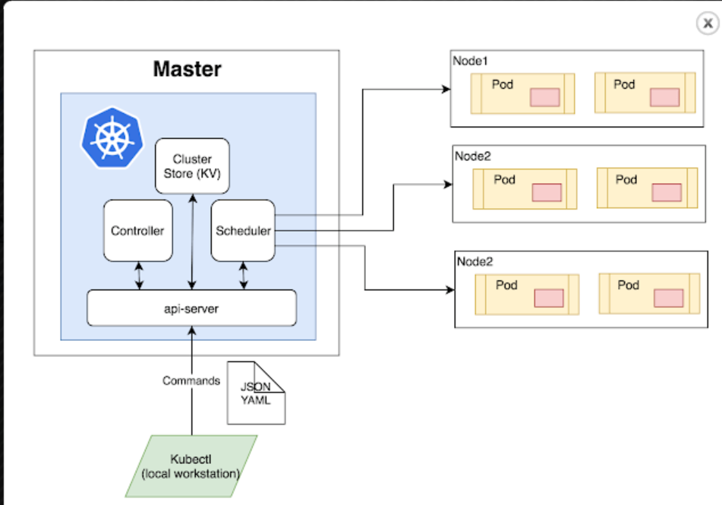
- Master Node: The master node is the first and most vital component which is responsible for the management of Kubernetes cluster. It is the entry point for all kinds of administrative tasks. There may be more than one master node in the cluster to check for fault tolerance.
- API Server: The API server acts as an entry point for all the REST commands used for controlling the cluster.
- Scheduler: The scheduler schedules the tasks to the slave node. It stores the resource usage information for every slave node. It is responsible for distributing the workload.
- Etcd: etcd components, store configuration detail, and wright values. It communicates with the most component to receive commands and work. It also manages network rules and port forwarding activity.
- Worker/Slave nodes: Worker nodes are another essential component that contains all the required services to manage the networking between the containers, communicate with the master node, which allows you to assign resources to the scheduled containers.
- Kubelet: It gets the configuration of a Pod from the API server and ensures that the described containers are up and running.
- Docker Container: Docker container runs on each of the worker nodes, which runs the configured pods.
- Pods: A pod is a combination of single or multiple containers that logically run together on nodes.
* List various services available in Kubernetes
Various services available in Kubernetes are 1) Cluster IP service, 2) Load Balancer service, 3) Node Port service, 4) External Name Creation service.
*What is kubelet :
The kubelet is a service agent which controls and maintains group of pods by checking pod specification using Kubernetes. The kubelet runs on each node and allows to communicate between a master node and a slave node.
*What is Kubectl used for?
Kubectl is a software for controlling Kubernetes clusters. Ctl stands for control, which is a command-line interface to pass the command to the cluster and manage the Kubernetes component.

*Define Stateful sets in Kubernetes
The stateful set is a workload API object that is used to manage the stateful application. It can also be used to manage the deployments and scaling the sets of pods. The state information and other data of stateful pods are store in the disk storage, which connects with stateful set.
*What is the Kubernetes Network Policy?
Network Policy defines how the pods in the same namespace would communicate with each other and the network endpoint.
*What is Kubernetes proxy service?
Kubernetes proxy service is a service which runs on the node and helps in making it available to an external host.
*What is a Namespace in Kubernetes?
Namespaces are used for dividing cluster resources between multiple users. They are meant for environments where there are many users spread across projects or teams and provide a scope of resources.
*How can you get a static IP for a Kubernetes load balancer?
A static IP for the Kubernetes load balancer can be achieved by changing DNS records since the Kubernetes Master can assign a new static IP address.
*Name the process which runs on Kubernetes Master Node?
Answer: The process that runs on Kubernetes Master Node is called the Kube-apiserver process.
What is blue green deployment in DevOps?
Blue/green deployments enable you to launch a new version (green) of your application alongside the old version (blue), and monitor and test the new version before you reroute traffic to it, rolling back on issue detection.

What is Canary Deployment?
A canary deployment is a deployment strategy that releases an application or service incrementally to a subset of users. All infrastructure in a target environment is updated in small phases (e.g: 2%, 25%, 75%, 100%).

